**Install Commerce Scale Unit on a development environment.**

# **Step 1 : Create Azure Active Directory apps:**

Create two Azure Active Directory (Azure AD) apps, one for CSU (Retail Server) and other for the Store Commerce for Web app (formerly CPOS).

* **CSU App (Retail Server) :**

1. Select App registrations, and then select New registration to open the Register an application dialog box.
2. Set the following fields:
3. **Name –** (Custom Retail Server)
4. **Support account types –** Select the default option, Accounts in this organizational directory only (Microsoft only - Single tenant).
5. **Redirect URI –** Leave it blank.
6. **Service Tree ID –** Leave it blank.
7. Select Register. The configuration page for the newly registered app appears.
8. In the Overview --> Essentials section, select Add an Application ID URI, and then select Set next to Application ID URI. Make a note of the suggested value, and then select Save to accept that value.
9. Select Add a scope, and then set the following fields:
10. **Scope name –** Enter a custom name for the scope. For example, enter Legacy.Access.Full.
11. **Who can consent –** Specify whether both admins and users or only admins can give consent, based on your organization's security policies.
12. **Admin consent display name –** Enter a display name. For example, enter Access Retail Server.
13. **Admin consent description –** Enter a description. For example, enter Gives access to Retail Server APIs.
14. Select Add scope to complete the scope creation process.

* **Store Commerce App:**

1. Select App registrations, and then select New registration to open the Register an application dialog box.
2. Set the following fields:

**Name –** Custom Store Commerce for web.

**Support account types –** Select the default option, Accounts in this organizational directory only (Microsoft only - Single tenant).

**Redirect URI –** Need to provide the newly created CPOS link, keep it blank for now.

**Service Tree ID –** Leave it blank.

1. Select Register. The configuration page for the newly registered app appears.
2. In the **Manifest** section, set the **oauth2AllowIdTokenImplicitFlow** and **oauth2AllowImplicitFlow** parameters to true, and then select Save.
3. In the Token configuration section, follow these steps to add two claims:
4. Select Add optional claim. Set the Token type field to ID, and then select the sid claim. Select Add.
5. Select Add optional claim. Set the Token type field to Access, and then select the sid claim. Select Add.
6. In the API permissions section, select Add a permission.
7. On the APIs my organization uses tab, select the first app which is Retail Server app that you created. Then select Add permissions.

# **Step 2 : Create an SSL certificate:**

Run the below script in Power shell (open as admin) to create SSL certificate. Edit the HostName and CertificateName.

$params = @{

DnsName = 'HostName’

CertStoreLocation = 'Cert:\LocalMachine\My'

FriendlyName = 'CertificateName’

KeyUsage = 'DigitalSignature','KeyEncipherment','DataEncipherment'

Provider = 'Microsoft RSA SChannel Cryptographic Provider'

HashAlgorithm = 'SHA256'

}

New-SelfSignedCertificate @params

# **Step 3 : Install the certificate:**

1. Win+r 🡪 mmc.exe 🡪 File 🡪 Add/Remove Snap in 🡪 Under Available snap-ins, select Certificates, and then select Add 🡪 In the Certificates snap-in dialog box, select Computer Account, and then select Next 🡪 Select Local Computer, and then select Finish 🡪 ok.
2. Expand **Certificates 🡪 Personal 🡪 Certificates 🡪** Locate the SSL Certificate you created 🡪 right-click and select **All Tasks 🡪 Export 🡪** Select **No, do not export the private key,** and then select **Next 🡪** Select **DER encoded binary X.509 (.CER) 🡪** Select the C:\temp folder, and then enter "DevBoxSelfSigned" as the file name.
3. Install the certificate 🡪 right click install 🡪 local machine 🡪 (put the path to Trusted root) Import the certificate in trusted.
4. Upload this certificate to the CSU (Retail Server) app registration.

# **Step 4 : Update Commerce headquarters**

### Enter the application ID(client ID) in headquarters

1. Go to System administration > Setup > Azure Active Directory applications (Microsoft Entra ID Applications).
2. In the **Client ID** column, enter both the application ID’s (client ID).
3. in the **Name** column, enter application name.
4. In the **User ID** column, enter "RetailServiceAccount".

# **Step 5 : Create a new channel database record**

To create a new channel database record in headquarters, follow these steps.

1. Go to **Retail and Commerce > Headquarters Setup > Commerce Scheduler > Channel Database.**
2. Select **New**.
3. For **Channel Database ID**, enter "DevSealedCSU".
4. For **Channel Database Group**, enter "Default".
5. Select **Save**.
6. On the **Retail Channel** FastTab, select **Add**.
7. Select the store you normally work with.
8. Select **Save**.
9. On the **Mapping a New Retail Channel** warning dialog box, select **Yes**.
10. Select **Download > Configuration file**.
11. Save the configuration file to C:\temp.
12. Rename the configuration file to "StoreSystemSetup.xml".

### **Step 6 : Create a new channel profile**

1. Go to Retail and Commerce > Channel Setup > Channel Profiles.
2. Select New.
3. For **Name**, enter "DevSealedCSUProfile".
4. Select Save.
5. Under **Profile Properties**, select **Add**.
6. For **Nonexternal VM connectivity**, enter the following:
   1. For **Property Key**, enter the property key value.
   2. For **Retail Server URL**, enter https://<HostName>:446/RetailServer/Commerce.
   3. For **Cloud POS URL**,

enter https://<HostName>:446/POS.

1. Go to Retail and Commerce > Channels > Stores > All Stores.
2. For each store record you normally work, update the following:
   1. For **Live Channel Database**, enter "DevSealedCSU".
   2. For **Channel Profile**, enter "DevSealedCSUProfile".
   3. Select **Save**.

**Note**

If you get a warning saying "The store's closing method must be set to 'Shift'", on the **Statement/Closing** FastTab of the store, update the **Closing Method** value to **Shift**.

Paste the CPOS URL to Store Commerce Application Redirect URI

Add a platform 🡪 Single-page application 🡪 https://<HostName>:446/POS/

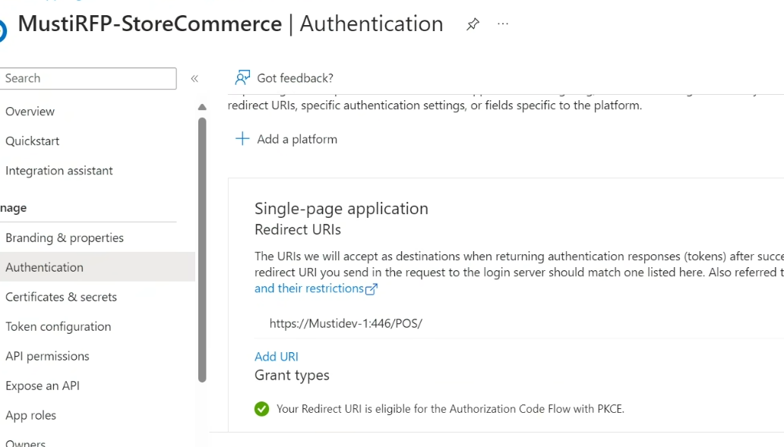

### Update CDX data groups

To update Commerce Data Exchange (CDX) data groups in headquarters, follow these steps.

1. Go to **Retail and Commerce > Distribution Schedule**.
2. Select the **Default Data** group.
3. Remove the default database record from this group, which will prevent future errors when trying to replicate to this database.

### Execute sync jobs

To execute sync jobs in headquarters, follow these steps.

1. Go to **Retail and Commerce > Retail and Commerce IT > Distribution Schedule**.
2. Select the **9999** job.
3. Select **Run now**.
4. For each warning, select **Yes**.
5. Select **OK** to schedule the job.

# **Step 7: Install sealed CSU prerequisites**

Before you install the Sealed CSU, you must install the .NET 6.0

1. [Download .NET 6.0 (Linux, macOS, and Windows](https://dotnet.microsoft.com/en-us/download/dotnet/6.0).
2. In the **ASP.Net Core Runtime 6.0.X** section, select the **Hosting Bundle** installer for Windows to download it.
3. Run the **dotnet-hosting-6.0.x-win.exe** installer.

**Download the sealed self-hosted installer to the development machine.**

LCS🡪 Shared Asset Library 🡪 Retail Self-service package 🡪 install respective version sealed CSU installer.

If you don’t have a CSU sealed installer in the list, select Import, select the sealed installer version you want to use, select Pick, and then select the package name to start the download.

Copy the sealed installer from the **Downloads** folder to C:\temp

# **Install the sealed CSU**

Command prompt (better to install it in powershell script as few issues are getting in RSSU) 🡪 CD C:\temp 🡪

CommerceStoreScaleUnitSetup.exe install --port 446 --SSLCertThumbprint "<SSL thumbprint of certificate created earlier>" --RetailServerCertThumbprint "<SSL thumbprint of certificate created earlier>" --AsyncClientCertThumbprint "<SSL thumbprint of certificate created earlier>" --AsyncClientAADClientID "<CSU Azure APP Client ID>" --RetailServerAADClientID "<CSU Azure APP Client ID>" --CPOSAADClientID "<CPOS Azure APP Client ID>" --RetailServerAADResourceID "<CSU Azure APP Client ID>" --Config "c:\temp\StoreSystemSetup.xml" --SkipSChannelCheck --trustSqlservercertificate

<SSL thumbprint of certificate created earlier> = Thumbprint of created SSL certificate (in UPPERCASE

<CSU Azure APP Client ID> = Client ID of CSU application

<CPOS Azure APP Client ID> = Client ID of Commerce application